Signal Control Loop Sensor
Fire Alarm Protectors FA 12V B and 30VB are surge protectors for “B” type zones or loops of either 12-volt or 24-volt. Protectors are 3-stage with primary and secondary protection that will greatly reduce false alarms caused by lightning and will protect the equipment. Units are encapsulated with a heat dissipating epoxy, which greatly enhances component performance.
Specifications for Fire Alarm
Zone Protectors
• Connection: Terminal Board
• Technology: Hybrid Circuit
Multi-Stage Design
Full Heat sinking
• Response: < 5 Nanoseconds
• Operating Temperature: -40⁰C - +85⁰C
• Operating Environment Weather Proof
• Voltage: Voltage Sensitive
• Current: Non Load-Bearing
No Follow -On Current
• Clamping Point: 15 or 30 or 64 Volts
• Power Dissipation: 2,000,000 Volt Amps /
Line
4,000,000 Volt Amps /
Line Pair
• Lines Protected: l Pair (“B” Zone)
2 Pair (“A” Zone)

• UL 497 listed • Tested to ANSI/IEEE B-3 Impulse

S

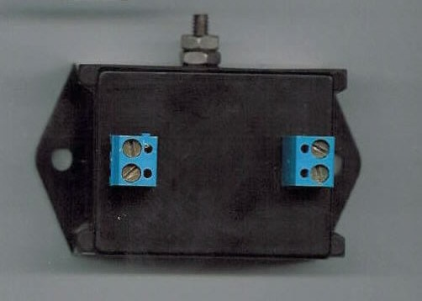

Fire Alarm Class A is 2 Pair, Class B is 1 Pair
FA 12VA 12V”A” Zone Protector - 2 Pair
FA 12V B 12V”B” Zone Protector - 1 Pair
FA30VA 24V”A” Zone Protector - 2 Pair
FA30VB 24V”B” Zone Protector – 1 Pair
FA30VB-BH 24V+ 3 amps ”BH” Bells Horns - 1Pair
FA60VB 34.8V+”B” Zone Protector -1 Pair
FA60VB-NC 34.8V+ 3amps ”B-NC” Bells Horns –
1 Pair

.

In-line Series Hybrid Three Stage AC Surge Suppressor
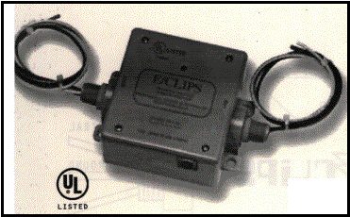

120HWCP20CB
This Unique Product is designed to provide superior transient voltage surge protection & noise reduction for Branch Circuits, Fire Alarms, PLC, NC/CNC, Controls, Card Access, Gate Access, Telemetry, (2)units in a 120/120 240 single phase application for PLC or Computer related PC board power supply drawing no more the 20 amps per line. This unit will eliminate a high degree of noise coming in the AC power, caused by HVAC, Pumps, Motors and other noisy equipment that can cause false alarms especially on Fire Alarm panels, or harmful effects affecting the performance of the PC board.

Specifications – Operating
Maximum Operating Voltage 135 Volts
Follow on current none
Circuit Breaker 20 amps
Connection In-Line series Hardwired
Operating Temperature -32to 85 C
Maximum Surge Current (8 x 20us) 300KVA
Maximum Surge Voltage (1.2 x50us) 20K Volts
TVSS Device UL File E121637
UL 1449 RVSS Rating 330 Volts L/N, N/G, L/G
Clamping Point 138 Volts RMS, 198V Peak
Clamping Response Time <5 nanoseconds
Maximum Line Amperage 20 Amps @120 VAC 45/60Hz

Active Filtering Dual-Full P-N,N-G Response 1Pico
Three Stage Filter 40dB down-10KHz to 10 Mhz
Power Dissipation (8x 20us) 3000 Joules, or 12,000KVA
Failure Mode Fails Safe (open) UL 1449 2nd edition
Dimensions Depth: 2.5”, Width: 4.5” Length 5”
Mounting (4) .5” tabs & (2) ½” nipples
Installation P/N/G(3)wire Line in,(3)wire load out
Weight Approximately 2.5 Pounds
6000V @ 3000amps 8 x20 us 220V Peak P/N,
ANS/IEEE Cat. B3 265VPK P/G, 207 VPK N/G

Surge Suppressors

